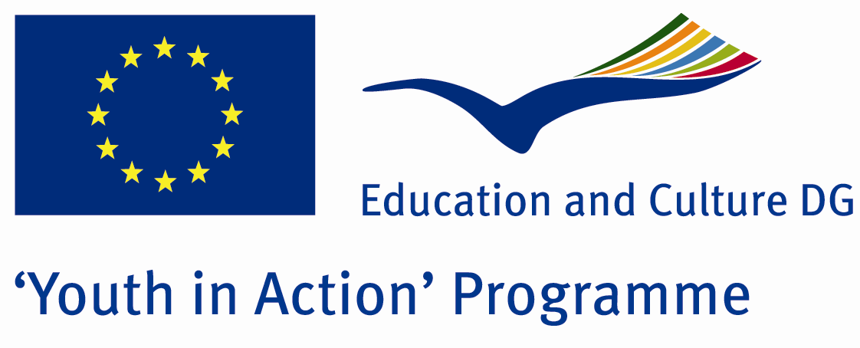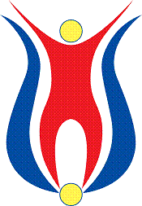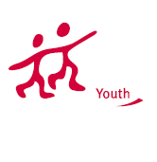

Action 4.3
Project Summary; Which handicap can overcome the human’s determination and happiness in life? Or how much are we brave to face up the barriers? There are many people facing up those barriers; in order to understand them better and come up with new ideas to develop their social lives we invite you to attend in our project. Not only having time and helping the educational process of the disabled people we are in Muğla. And you?

Project Title; LİFE WİTHOUT DİSABLED
Date and Venue ; 24-30 August Turkey
Place: Bartın.

Target Group ; Municipalities, City Councils and Non-Governmental organizations,
youth groups,culture and art groups,e.t.c

Participants ; 5 people from each country (over 18 -25 ). Totally 8 countries.

Conditions ; Accommodation, board and programme costs will be financed through European Commission Youth in Action Programme . Travel costs will be reimbursed in 70% (APEX Tarrifs). Organizations from all 27 EU member countries plus Liechtenstein , Norway and Iceland are eligible to take part.

Working language: English

Organisator group: Life without Disabled
How to apply: If you are interested, please send your Part III forms to
by e-mail please (in word file). Scan Part3 format is enough for application.(Fulfilled Part III which you can find in the attachment, of course signed and stamped) ..

Contact e-mail:grouplifegrouplife@gmail.com

